Tools used

In the project, a demonstration of the use of artificial intelligence for the recognition of musical instruments based on their timbre is made. As timbre is defined as the spectral form of the frequencies from which harmonics result, timbre can be taken over with the help of the fast Fourier transform. In order to be able to recognize the specific timbre of each instrument, an artificial neural network is trained with a training dataset that includes sufficient data with the selected musical instruments to train the artificial neural network model. To train the artificial intelligence model, TensorFlow is used, through which advanced model training algorithms can be accessed. The CNN convolution network algorithm is specifically used in this application. The Tensorflow platform is accessed via the Keras API using the Python language.

Preparing the dataset for training

In order to prepare the data for the training dataset, 3 types of musical instruments were initially selected: Accordion, Violin and Trumpet. For each type of instrument, 45 individual instruments have been selected. For each instrument, 15 recordings were recorded comprising the notes of instruments from A2 to C4. That means 675 recordings per instrument type and 2025 recordings in total. The instruments were selected from the Halion7 app which contains a musical instrument library that contains recordings of each instrument for each musical note. The sounds were recorded from the phone for a duration of 14 seconds, but were later truncated to 3 seconds for the calculation of the Fourier transform. After that, the recordings were converted to mono and the volume normalized. The recordings are in WAV format at 16bit resolution recorded at a sample rate of 44100Hz.

Processing the training dataset

In order for the AI model to be able to learn from the training dataset, the training data needs to be adapted so that it can make the specific information that contains the timbre of musical instruments evident. The recordings being of the mono WAV type, they contain the samples in the time domain.

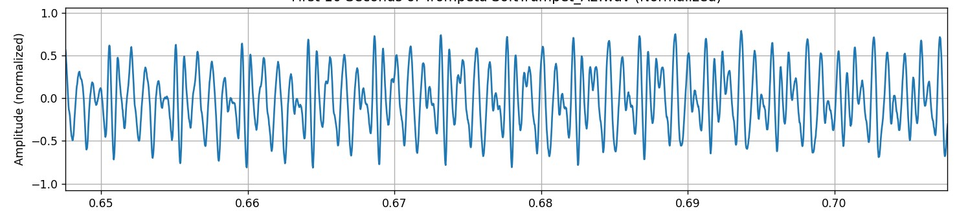

Fig. 24 Waveform for the A2 note of a trumpet for a 0.05-second section

For this purpose, the Fast Fourier transform is used, which extracts the spectral components from the audio signal, which makes visible the specific character of each instrument. After applying the Fourier transform, features such as the root note and the distribution of sound harmonics can be highlighted. Since by applying the Fourier transform a complex number is obtained, real part, imaginary part, for a precise representation the amplitude is taken as the absolute value ∣A∣ = .$\sqrt{{Re}^{2}+{Im}^{2}}$
From the resulting spectrum of musical instruments, the specific features of each instrument can be highlighted. For comparison, the note G3 for Accordion, Violin and Trumpet is taken.

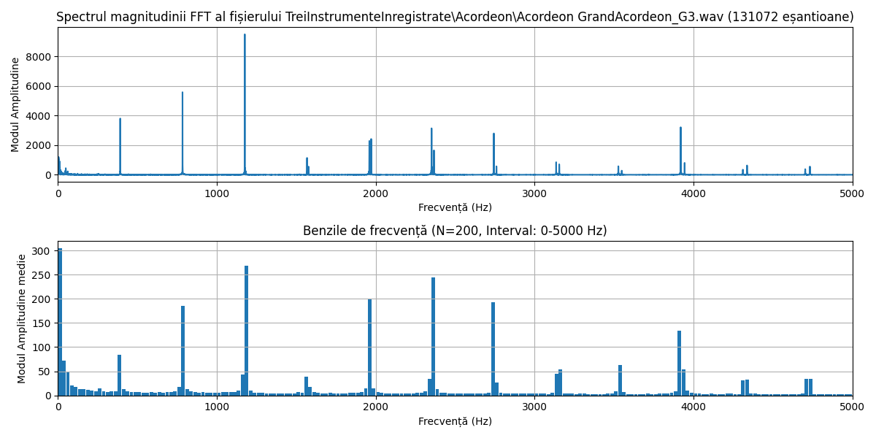

Fig. 25 The spectrum for the G3 note of an accordion
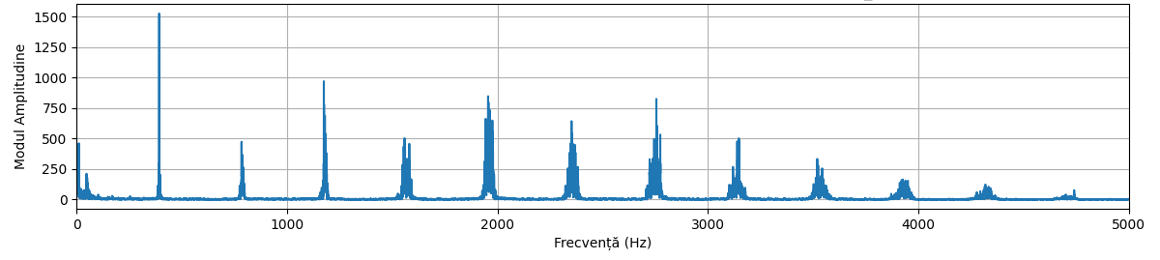

Fig. 26 Spectrum for the G3 note of a violin
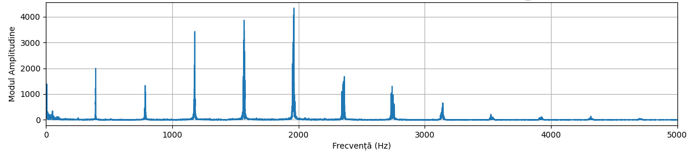

Fig. 27 The spectrum for the note G3 of a trumpet

According to the table in Fig. 7, the frequency corresponding to the note G is 392Hz, corresponding to the fundamental frequency. The harmonics will be multiples of the fundamental note, namely 784Hz, 1176Hz, 1568Hz, 1960Hz, 2376Hz... . Only the corresponding information in the range of 0-5000Hz was kept in the drive set because it happens that most of the information necessary to be analyzed in order to determine the timbre is concentrated in that range. One can easily see the distinction between the instruments. Only for the violin it is made that the amplitude of the highest frequency is the fundamental frequency, being subsequently present many harmonics, all about half the amplitude of the fundamental up to almost the frequency of 5000Hz.
For the trumpet, harmonics 3, 4 and 5 all have amplitudes higher than the fundamental frequency, later feeling the presence of 3 other harmonics of lower amplitudes. For the Accordion, on the other hand, the frequencies of harmonics 2 and 3 have the amplitude higher than the fundamental frequency, followed by a series of harmonics with relatively low amplitude. These characteristics of amplitudes specific to the fundamental frequency and harmonics are what can be the digital representation specific to the timbre of a musical instrument. The model trained with this data will need to be able to recognize these differences from the analysis of the frequencies of musical instrument signals.
Subsequently, a technique of reducing the frequency resolution (downsampling) necessary to extract the number of traits with which the input of the artificial neural network for training will be fed is applied to the resulting spectrum. The range 0-5000Hz is divided into bands then they are averaged. The resulting number of bands will coincide with the number of neurons on the first input layer of the artificial neural network. A small number of bands will increase the speed of pattern recognition and classification, but there is a risk that certain details will be lost. A higher number of bands corresponding to the input traits will require a higher number of neurons on the first layer and possibly the need for additional intermediate layers will arise, which will substantially increase the size of the model. Initially, it was found that a number of 200 input features would be enough to achieve the desired results.

Fig. 28 Framing the signal spectrum into 200 frequency bands

Artificial neural network model architecture

The proposed model is a one-dimensional convolutional neural network (Conv1D) using the algorithms from the TensorFlow platform, specially adapted to be able to recognize musical instruments by recognizing the timbre characterized by the spectral distribution of frequencies. This architecture is done through an efficient approach to recognizing characteristics from sequential data that are represented by frequencies. The model uses several convolutional and dense operations that extract and interpret relevant features from the frequencies of audio signals.
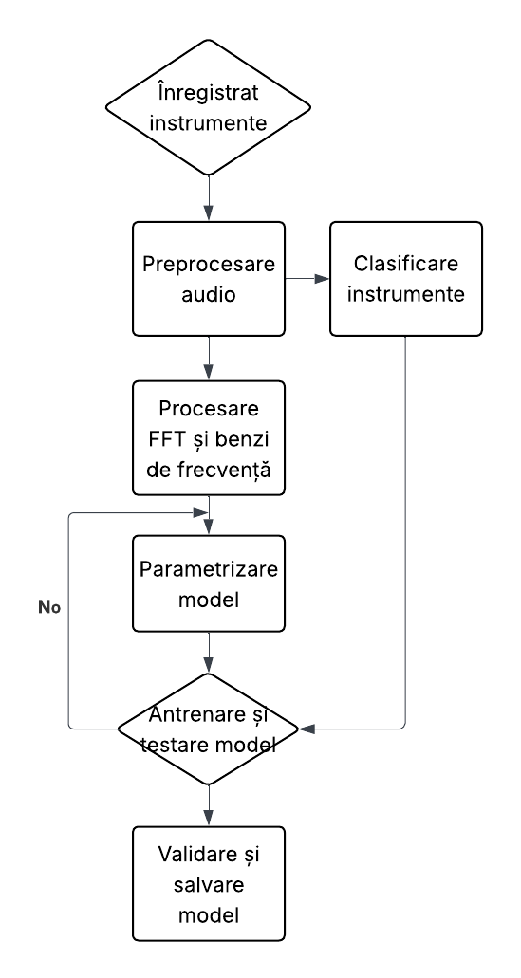

Fig. 29 Stages of Artificial Neural Network Training

The network receives as input a one-dimensional vector of 200 values, corresponding to the frequency bands extracted from the original signal. These are treated as a linear sequence, and each value is considered a point in frequency, which makes the use of a Conv1D network usable. The first layer is a convolutional layer with 64 filters and a size 3 kernel window. This layer examines the signal and extracts local characteristics, subtle variations in amplitude and frequency that can differentiate one instrument from another. The activation used is ReLU, most often used in such models.
After this layer, a max pooling operation with a size 2 window follows, which reduces the size of the output and makes the model more robust to minor variations in the data. To prevent overfitting, the dropout technique is used, which randomly deactivates 30% of neurons during training at each training step. This is followed by a second, deeper convolutional layer with 128 filters, which allows the model to recognize more abstract and general features, built on the previously extracted ones. The same techniques are applied to this layer as the previous layer of max pooling and dropout, which maintain a balance between complexity and regularization.
The convolutional output is flattened, turning the multidimensional matrix into a one-dimensional vector that can be processed by dense layers. This vector is introduced into a dense layer fully connected with 64 neurons and ReLU activation, which learns complex combinations between the extracted traits. The same dropout technique is applied to reduce the risk of overfitting. Finally, the output is passed through a dense layer with 3 neurons and softmax activation, generating the probability distribution on the three classes of musical instruments: accordion, trumpet and violin.
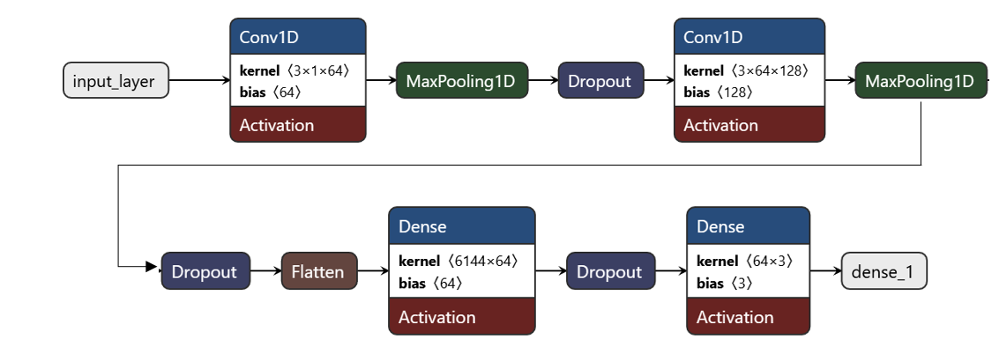

Fig. 30 Convolution Neural Network Architecture

Performance evaluation parameters

Once a model is trained, we need to evaluate its performance not just through a single metric like accuracy, but from multiple perspectives. There are several parameters that are used depending on the type of problem, in this case a classification problem. Of these, the most important would be the loss function, accuracy, learning curves, confusion matrix or loss value on the test set.

Learning curves: loss and accuracy

Two fundamental tools in evaluating performance are the loss curve and the accuracy curve. They provide complementary insights into how the model adapts to the data, highlighting both performance and potential issues. The loss measures the model's error in predictions, reflecting how far its estimates are from the actual values. The purpose of training is to minimize this function, and its evolution indicates the degree of learning. On the other hand, accuracy shows the percentage of correct predictions, providing a more intuitive measure of the model's success. In the initial phase of training, both curves show rapid changes. Losses decrease significantly, and accuracy increases. This indicates that the model is starting to learn correctly. As the workout progresses, the improvements gradually become smaller, and the curves tend to stabilize. The ideal behavior of a well-trained model involves a constant decrease in loss and a constant increase in accuracy on both the training and validation sets. The small differences between the two sets indicate a good generalization. If learning losses continue to decrease, but at validation they start to increase, it is a clear sign of overfitting. The model memorized training data instead of learning general patterns, becoming unable to recognize from new data. On the other hand, if both losses and accuracy remain weak on both sets, the model suffers from underfitting, i.e. it is too simple to capture the complexity of the data.
When the model overfits, certain strategies should be adopted, such as introducing regularizations such as the use of abandon or reducing the number of parameters. Augmenting training data can also improve generalization. In the case of underfitting, the solutions consist of increasing the complexity of the model, choosing a more efficient optimizer or training with several epochs.
For the musical instrument identification app, the learning curves for accuracy and loss indicate a good learning rate. Losses initially drop sharply after 10 epochs and become very close to 0 after 20 epochs on both the training set and validation.

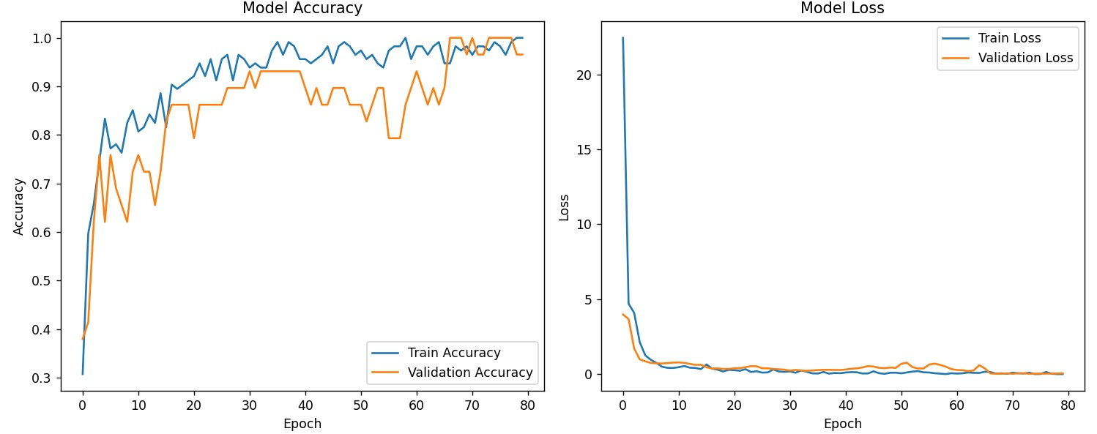

Fig. 34 Loss learning curves and accuracy for the musical instrument identification application

Model performance

The accuracy on the drive set increases significantly from ~32.4% (epoch 1) to ~98.2% (epoch last), indicating that the model is learning from the data. The accuracy on the validation set increases from ~44.8% to ~93.1%, which is a good sign that the model is generalizing. The loss per drive drops from 16.73 to 0.059, which confirms that the pattern is converging. The loss on validation drops from 7.13 to ~0.39–0.52 (with some oscillations), suggesting a good generalization, but not perfect. In last epochs, the accuracy per test (>95%) is significantly higher than the accuracy per validation (~90–93%), and the loss per validation has oscillations (sometimes increases slightly). This may indicate slight overfitting, but not extreme, as performance on validation continues to be good. Best accuracy on validation: 96.55% is observed at epoch 29. Lowest loss per validation: ~0.35 at epoch 20.
From the analysis of this data it can be said that the model has good performance (accuracy - validation >90%), but it could be improved to reduce easily slightly noticeable overfitting.
Era | Precision | Loss | Validation accuracy | Loss of validation
1 | 0.32456142 | 16.7313881 | 0.44827586 | 7.13830042
2 | 0.61403507 | 8.04368591 | 0.65517241 | 2.40476179
3 | 0.62280703 | 3.64150691 | 0.65517241 | 2.24835634
4 | 0.7280702 | 2.57574558 | 0.65517241 | 1.59467804
5 | 0.79824561 | 1.06094182 | 0.68965518 | 1.15797186
6 | 0.7280702 | 1.10233653 | 0.7241379 | 0.83934033
7 | 0.78070176 | 0.73346871 | 0.7241379 | 0.84147978
8 | 0.7631579 | 0.52121991 | 0.79310346 | 0.74117529
9 | 0.78947371 | 0.52655888 | 0.79310346 | 0.69107312
10 | 0.87719297 | 0.48888475 | 0.79310346 | 0.64788377
11 | 0.82456142 | 0.52863008 | 0.79310346 | 0.66937715
12 | 0.85964912 | 0.38257986 | 0.79310346 | 0.69248456
13 | 0.91228068 | 0.30365765 | 0.82758623 | 0.69640821
14 | 0.88596493 | 0.34697315 | 0.82758623 | 0.68423438
15 | 0.91228068 | 0.18696225 | 0.79310346 | 0.66299284
16 | 0.90350878 | 0.28827924 | 0.79310346 | 0.57023686
17 | 0.93859649 | 0.21282923 | 0.86206895 | 0.46181208
18 | 0.94736844 | 0.14062469 | 0.89655173 | 0.3962464
19 | 0.97368419 | 0.15251976 | 0.89655173 | 0.35557601
20 | 0.93859649 | 0.19156748 | 0.93103451 | 0.35173774
21 | 0.94736844 | 0.31907362 | 0.89655173 | 0.36721411
22 | 0.92105263 | 0.31812614 | 0.86206895 | 0.42760575
23 | 0.98245615 | 0.12469126 | 0.89655173 | 0.45134449
24 | 0.89473683 | 0.27045384 | 0.89655173 | 0.46627533
25 | 0.92105263 | 0.19152223 | 0.89655173 | 0.46733373
26 | 0.97368419 | 0.15853919 | 0.93103451 | 0.51953512
27 | 0.97368419 | 0.11530393 | 0.93103451 | 0.53274328
28 | 0.9649123 | 0.13681765 | 0.93103451 | 0.54877001
29 | 0.90350878 | 0.29477453 | 0.96551722 | 0.50224888

Table 1 Performance of the model by epoch during training

The Confusion Matrix

The confusion matrix is one of the most valuable tools for evaluating classification models. Through detailed analysis of errors and successes, it allows for more precise optimization than other general performance measures. Understanding it is essential in the design and optimization of artificial intelligence systems. It is a very helpful tool because, in addition to providing an insight into performance, it also provides clues where the system has shortcomings and could still be improved. This allows you to identify the weaknesses of the algorithm and make decisions to improve it.
A confusion matrix is a table that compares a model's predictions to the actual data values. In the case of a binary classification problem, the matrix has a simple form of 2×2, with four main categories:
- True Positive (TP): Instances correctly classified as positive.
- False Positives (FP): Negative instances wrongly classified as positive (type I error).
- False Negatives (FN): Positive instances wrongly classified as negative (type II error).
- True Negative (TN): Instances correctly classified as negative.

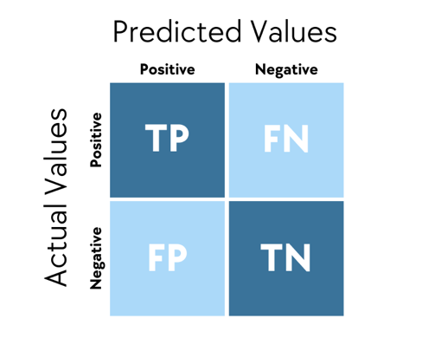

Fig. 35 Confusion matrix for binary values

In this case, for problems with multiple classes, such as the musical instrument identification app, the matrix expands to 3×3, with each row representing the actual cases and each column representing the predictions. By analyzing the confusion matrix, it is understood whether the model tends to erroneously identify a particular instrument as another. Purely demonstratively, the confusion matrix was taken for the model trained at 10 epochs. It can be seen from the figure attached below that there is a great tendency for the accordion to be identified as a violin, but in no case is it identified as a trumpet. The violin can also be identified as an accordion, but it cannot be confused with a trumpet. However, the trumpet has a probability of being confused with either the violin or the accordion. It can be concluded that the model does a little better at identifying the trumpet than the violin or accordion, so it should be trained a little more in recognizing the violin and accordion.

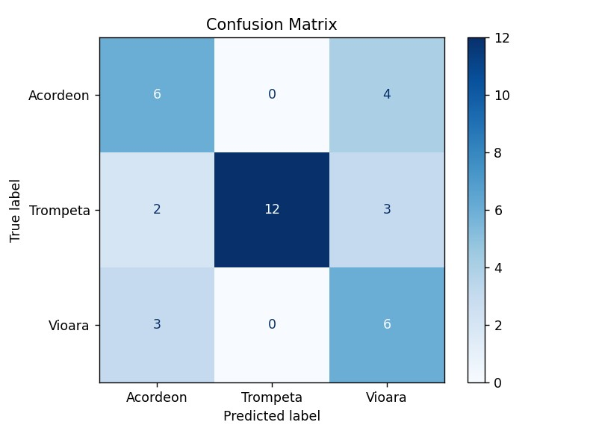

Fig. 36 Confusion Matrix for Musical Instrument Identification App

with the model trained up to 10 epochs.

By dragging the model up to the previously established optimal range of 20-29 epochs, more precisely up to 25 epochs, one can see the much increased accuracy of the model.
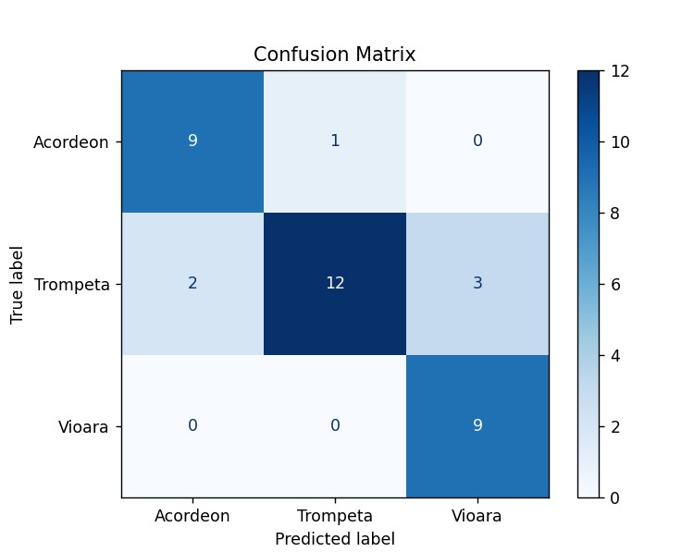

Fig. 37 Confusion Matrix for Musical Instrument Identification with the model trained up to 25 epochs

What is very interesting is that in the case of the trumpet there is no progress in not being confused with either the violin or the accordion. But in the case of the violin, the accuracy has increased astonishingly close to 100%, seeming unmistakable, while only once in 10 has the accordion been mistaken for the trumpet.

Model Accuracy

To test the model in real situations, a test set with recordings with instruments slightly different from those used in training was used. The goal is to calculate accuracy when the model is confronted with new data if it is able to generalize from what it has learned. Initially, 3 recordings were used for each instrument. For the accordion, the model correctly recognized 2 out of 3 instruments, in both cases with a score of ~0.85. For the violin and trumpet, 6 times in total, the model correctly recognized with a score of over 0.9. This means from a practical point of view that the model is able to recognize other instruments than those used in training.
In contrast, the model is not able to recognize the instrument when instruments with musical notes other than those used in training are used. For training, the notes of the instruments were between A2 and C4. When the model was tested with grades above C4, the model randomly indicates one of the three instruments or simply has a score of less than 0.75 which invalidates the result.

